**WireLoopAR**

**Game Overview**

*Game Concept*

Wire Loop  is a physics based 3D Augmented reality game. Move the phone in such a way that pin doesn’t touch the wire path and collect stars.

*Target Audience*

Anyone with smartphone with any ages.

*Genres*

* Physics Based game.
* Wire loop on android and VR.

**Gameplay**

*Objective*

* Starting from the start point and reaching the end point.
* Collecting stars during the game.
* Avoiding pin touching the wire.

*Game Progression*

* The progress of the game depends on reaching the end of level.
* No boss battle involved.

*Level Structure*

* Our game has 4 levels
* Level 1 - Easy
  + The easy level goes with a straight static wire.

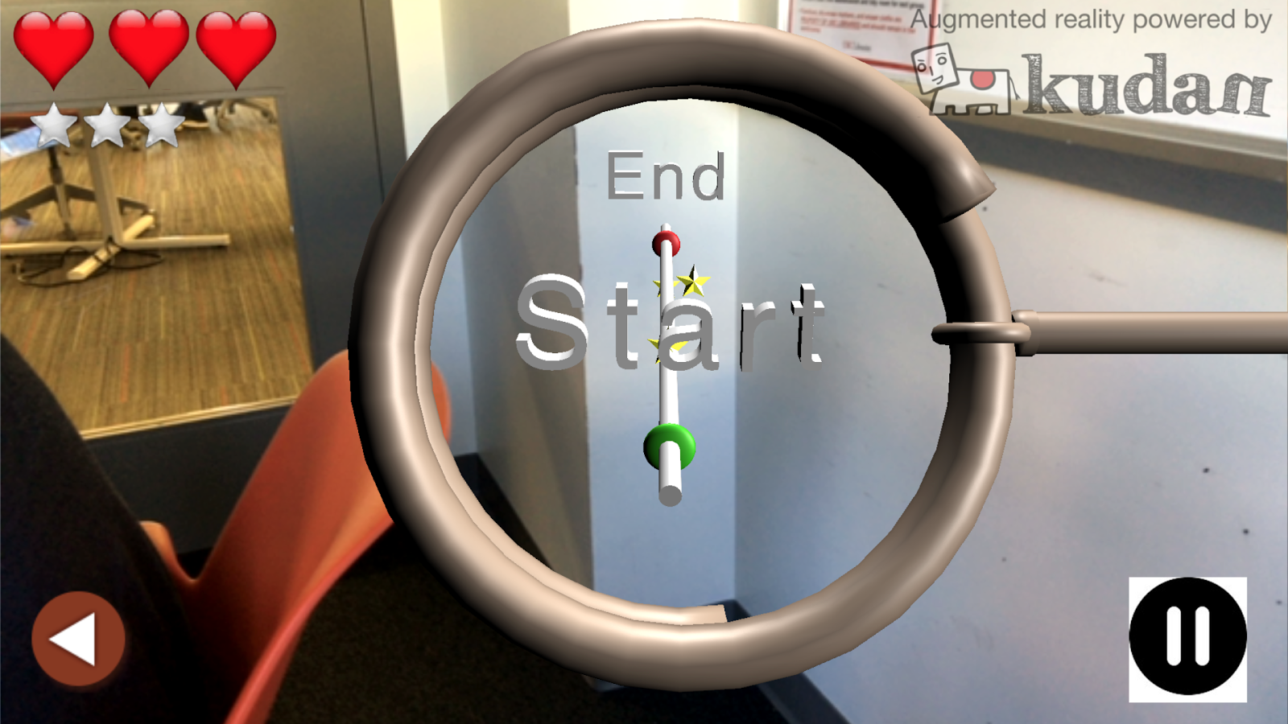

* Level 2 - Medium
  + The medium level goes with two static wires and a rotating wire.
  + The player has to pass one static wire first and pass the rotating wire very fast to reach the end point.

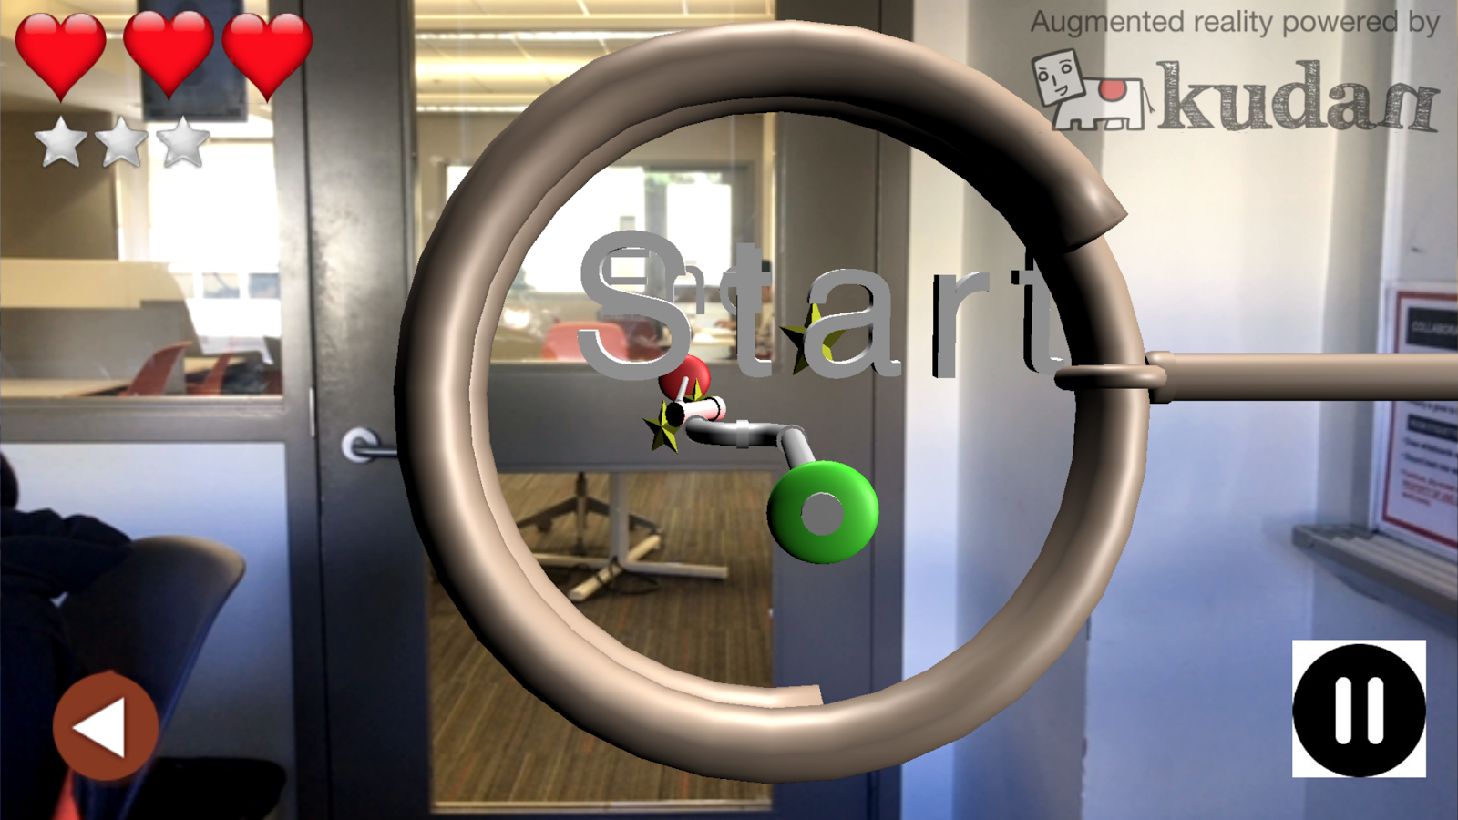

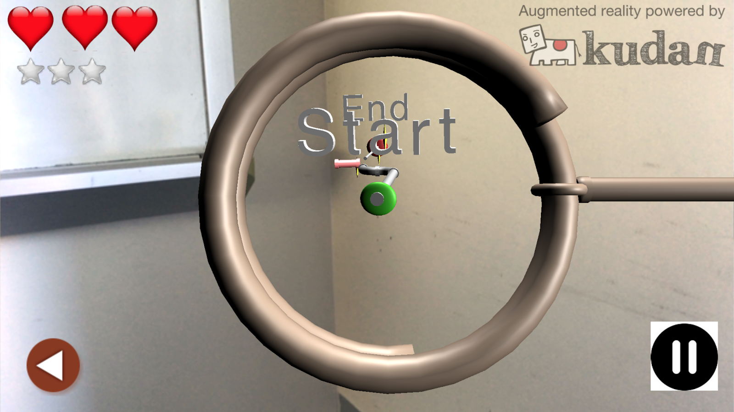

* Level 3 - Difficult
  + The hard level goes with 3 separate part of pipes
  + The user should pass the first part and get the star then for going to the second part the head and the end of pipes disappearing and appearing every 5 sec. So user should pass into the pipe when the head disappeared and exit the pipe part 2 when the end disappeared.
  + Then the user should get the third star from the third part of parts. And pass the end point

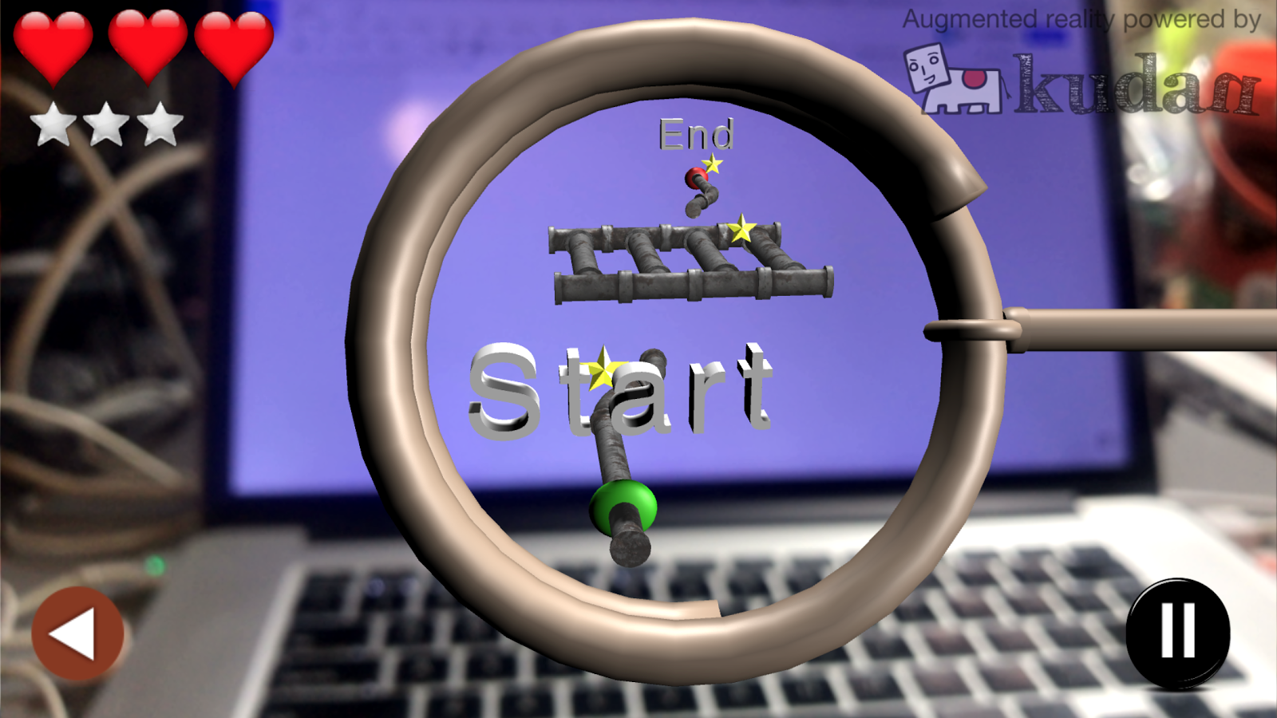

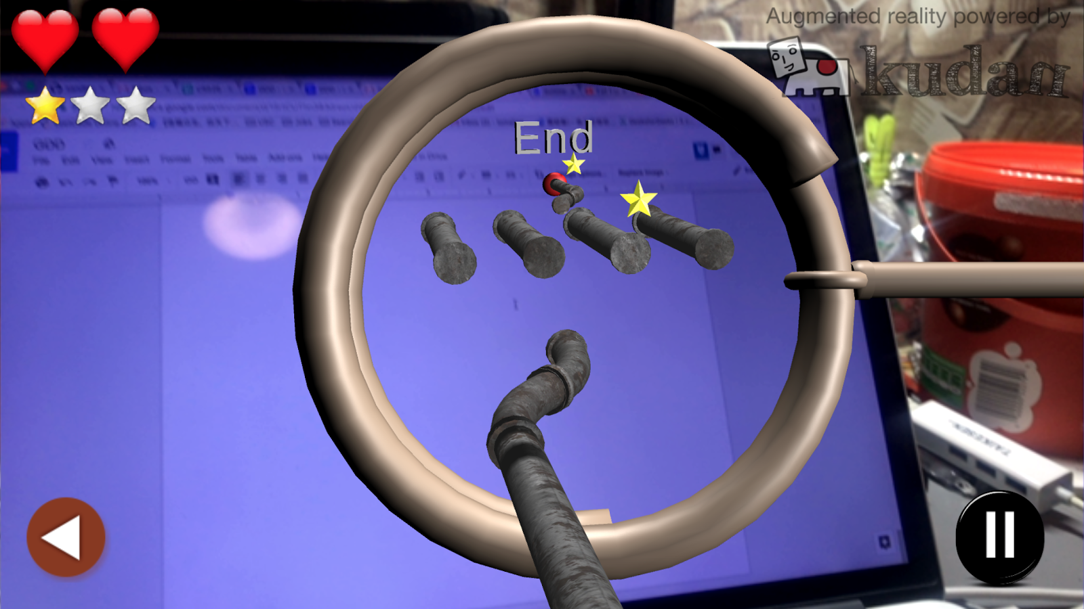

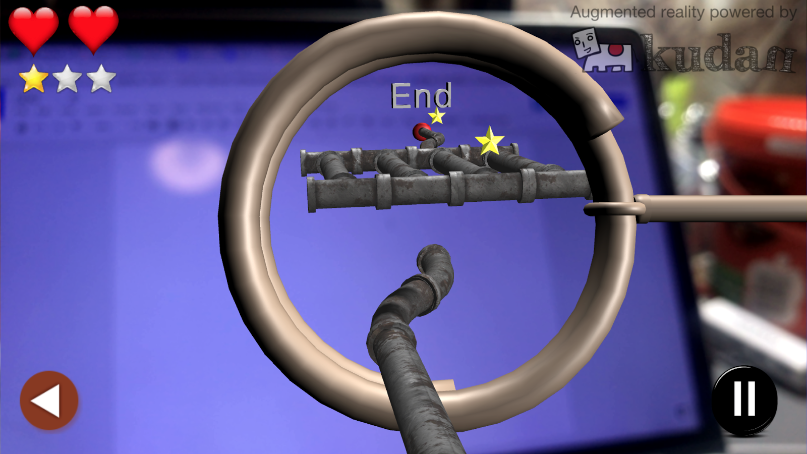

* Level 4 - Moving Star
  + The moving star level goes with a straight static wire while all the stars are moving all the time.
  + The player has to pass the straight wire while collects all three moving stars.

*Mechanics*

* The pin should avoid to touch the wire while collect stars.
* The game would provide shadow to indicate where the pin is right now.

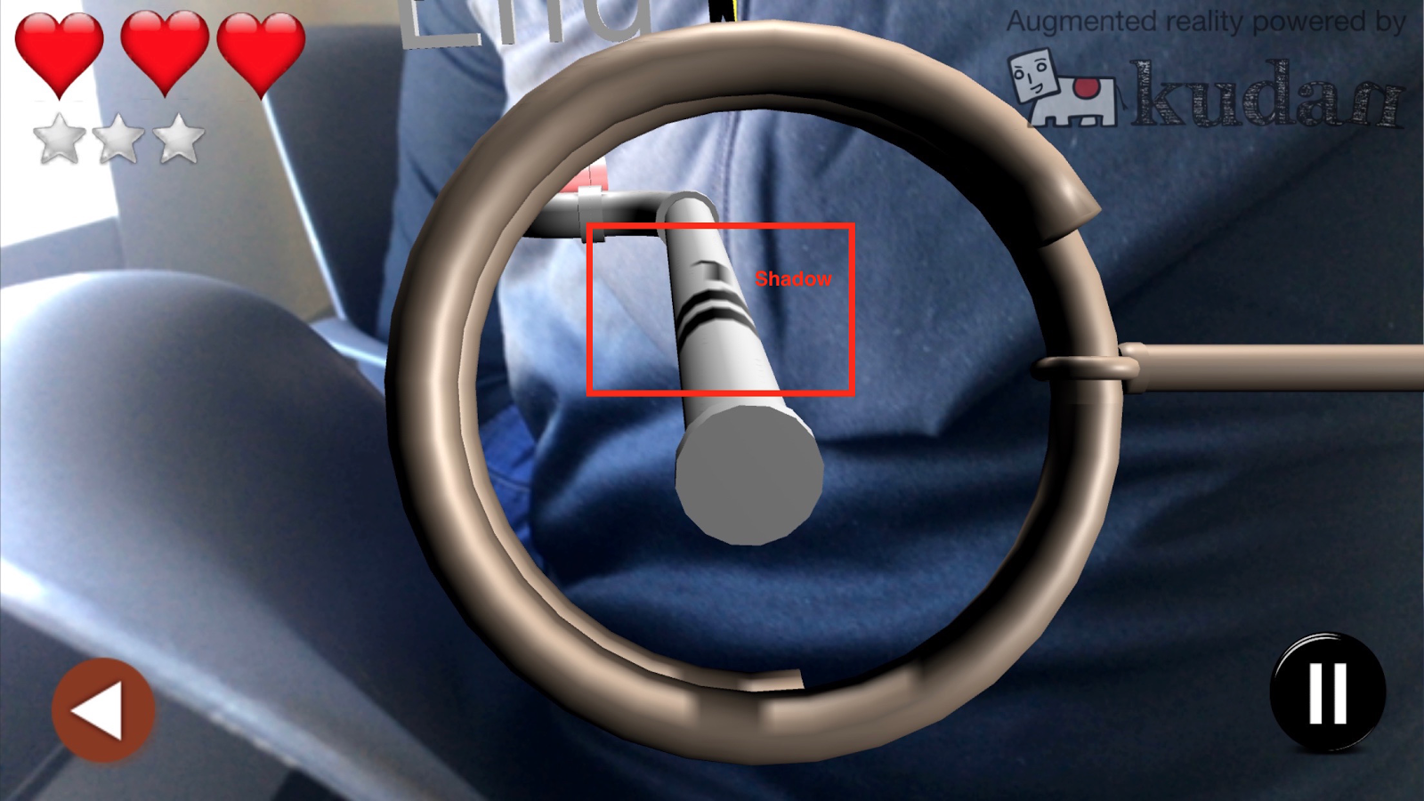

* The game would provide a distance indicator that turns yellow or red to warn the user, when the pin comes too close to the pipe.

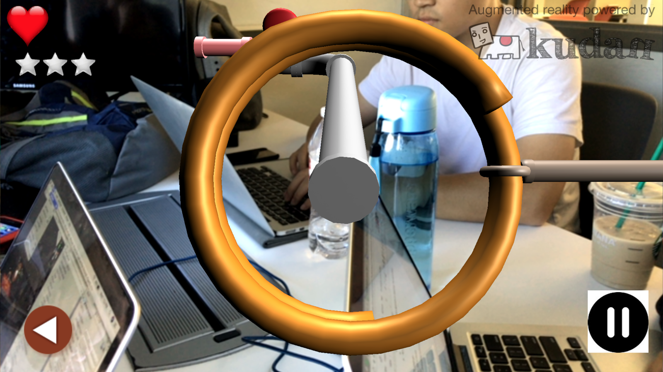

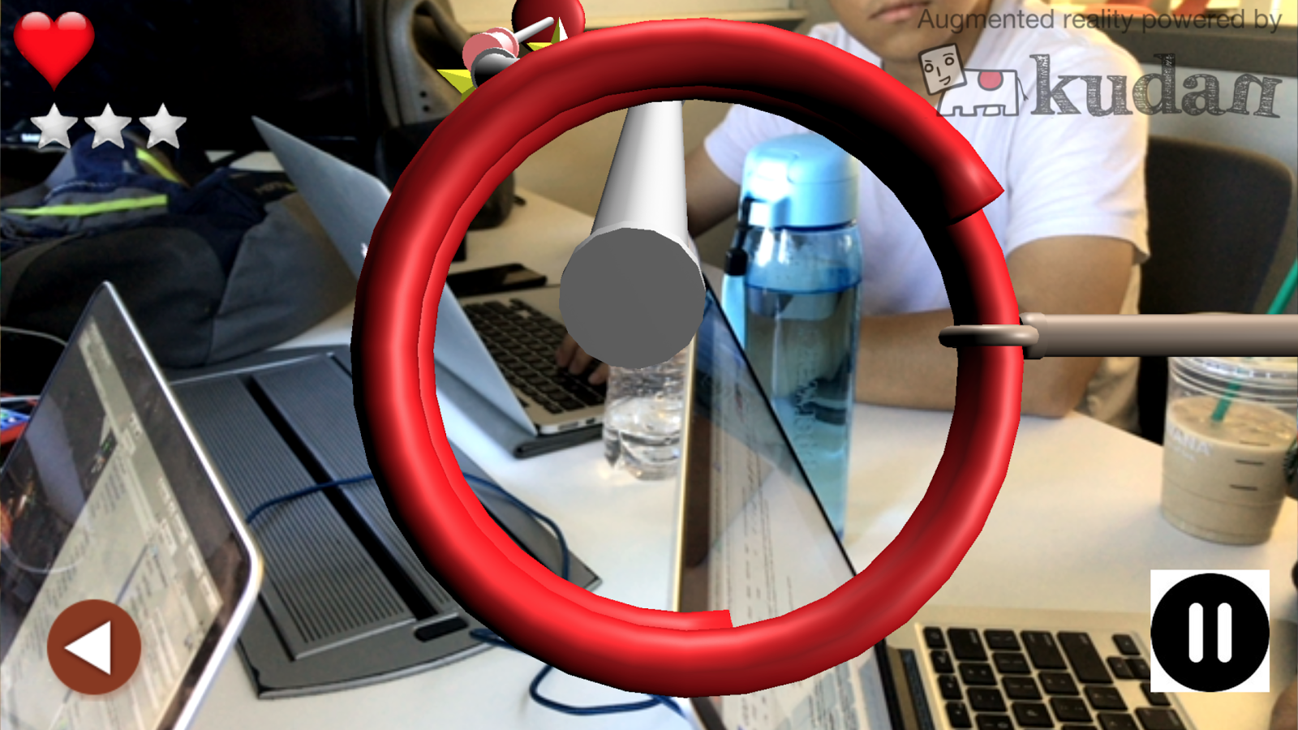

**Game World**

* The game world is the same as where the player is around right now.
* The game world is based on the real world.

**Technical Specification**

* Target platform is iPhone, Android, smartphones and tablets.
* Augmented Reality(AR).
* Unity3d, KudanAR.

**Team Member**

* Sandesh Hegde
* Yang Yang
* Tao Fang
* Basir Navab
* Qingfeng Han
* Xirui Feng